|  |  |
| --- | --- |
| Name | Umar Hayyat |
| Roll No | 2019-EE-360 |

**Lab 8**

**Writing Class**

**Objective:**

In this lab,

* I will learn how we use setter and getter method.
* I will learn how we declare a method.

**Task 1:**

Design and implement a class called Dog that contains instance data that represents the dog’s name and age. Define the Dog constructor to accept and initialize instance data. Include getter and setter methods for the name and age. Include a method to compute and return the age of the dog in “person years” (seven times the dogs age). Include a toString method that returns a one-line description of the dog. Create a driver class called Kennel, whose main method instantiates and updates several Dog objects.

**Code:**

public class Kennel {

public static void main(String[] args){

Dog dog1 = new Dog();

dog1.setName("Jay");

dog1.setAge(1);

dog1.newage();

System.out.println("Data of first Dog :");

System.out.println(dog1.toString());

Dog dog2 = new Dog();

dog2.setName("Banty");

dog2.setAge(2);

dog2.newage();

System.out.println("Data of second Dog :");

System.out.println(dog2.toString());

}

}

public class Dog {

private String name ;

private int age;

private int newage;

public Dog(){}

public void setName(String newname){

name = newname;}

public String getName(){

return name ;}

public void setAge(int newage){

age = newage;}

public int getAge(){

return age;}

public void newage(){

newage = 2*age;}

public String toString(){

return "Dog Name : "+name+"\t\tDog Age : "+newage+" year\n";

}

}

**Output:**

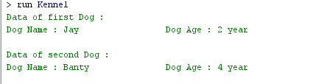

**Task 2:**

Design and implement a class called Box that contains instance data that represents the height, width, and depth of the box. Also include a boolean variable called full as instance data that represents whether the box is full or not. Define the Box constructor to accept and initialize the height, width, and depth of the box. Each newly created Box is empty (the constructor should initialize full to false). Include getter and setter methods for all instance data. Include a toString method that returns a oneline description of the box. Create a driver class called BoxTest, whose main method instantiates and updates several Box objects.

**Code:**

public class BoxTest {

public static void main(String[] args){

Box box1= new Box();

box1.setHeight(4);

box1.setWidth(3);

box1.setDepth(2);

System.out.println("Data of first Box :");

System.out.println(box1.toString());

Box box2= new Box();

box2.setHeight(6);

box2.setWidth(5);

box2.setDepth(3);

System.out.println("Data of second Box :");

System.out.println(box2.toString());

}

}

public class Box {

private int height;

private int width;

private int depth;

public Box(){}

public void setHeight(int newheight){

height = newheight;}

public int getHeight(){

return height;}

public void setWidth(int newwidth){

width = newwidth;}

public int getWidth(){

return width;}

public void setDepth(int newdepth){

depth = newdepth;}

public int getDepth(){

return depth;}

public String toString(){

return "Height : "+height+"cm\t Width : "+width+"cm\t Depth : "+depth+"cm\n";

}

}

**Output:**

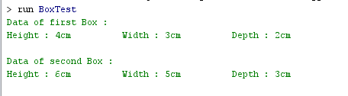

**Task 3:**

Design and implement a class called Book that contains instance data for the title, author, publisher, and copyright date. Define the Book constructor to accept and initialize this data. Include setter and getter methods for all instance data. Include a toString method that returns a nicely formatted, multi-line description of the book. Create a driver class called Bookshelf, whose main method instantiates and updates several Book objects.

**Code:**

public class BookShelfe {

public static void main(String[] args){

Book book1 = new Book();

book1.setTitle("Hmalet");

book1.setAuth("Rex Gibson");

book1.setPubl("Harold Bloom");

book1.setCopy("May");

Book book2 = new Book();

book2.setTitle("Core");

book2.setAuth("Cay ");

book2.setPubl("Prenl");

book2.setCopy("June");

System.out.println("Data of first Book : ");

System.out.println(book1.toString());

System.out.println("Data of second Book : ");

System.out.println(book2.toString());

}

}

public class Book {

private String title;

private String auth;

private String publ;

private String copy;

Book(){}

void setTitle(String newtitle){

title = newtitle;}

String getTitle(){

return title;}

void setAuth(String newauth){

auth = newauth;}

String getAuth(){

return auth;}

void setPubl(String newpubl){

publ = newpubl;}

String getPubl(){

return publ;}

void setCopy(String newcopy){

copy = newcopy;}

String getCopy(){

return copy;}

public String toString(){

return "Title : "+title+"\nAuthor : "+auth+"\nPublisher : "+publ+"\nCopyright : "+copy+"\n";

}

}

**Output:**

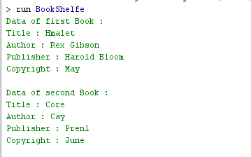

**Conclusion:**

In this lab, I also learnt how we declare a data and method in class. I also learnt how we can get and change the value of variable by using getter and setter method and I also use these method. I also learnt that how we can make any class and use it.